A two-sided Mind Map The root node of a mind map has two sides for arranging its children nodes. As the example shown in Fig 2, the root node (Topic) is placed at the center.

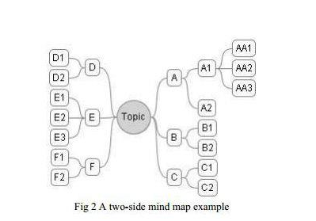

The Component class has a getSide() method to indicate the side of the node. The return value can be RIGHT, LEFT, or NONE. (The side-value of the root node is always NONE). The Component class has another method, getName(), that returns “A”, “A1”, or “AA1” for the nodes shown on the top right of Fig. 2. For now, we suppose a mind map has been created accordingly as we see in Fig 2. If a node is inserted as a child of another node, its side value is always the same as its parent node, except for the root node. (We do not care how to decide on the side value of direct children of the root for this lab.) Let‟s implement a DisplayNodeVisitor to print the following information for the mind map you see in Fig 2. – Topic Right nodes: 6 A nodes 3 B nodes 3 C nodes Left nodes: 3 D nodes 4 E nodes 3 F nodes